Joao Monteiro

Southern New Hampshire University

CS 330 Comp Graphics and Visualization

Professor: Brian Holbert

10/20/2024

**Project Screenshots**

LIGHTING

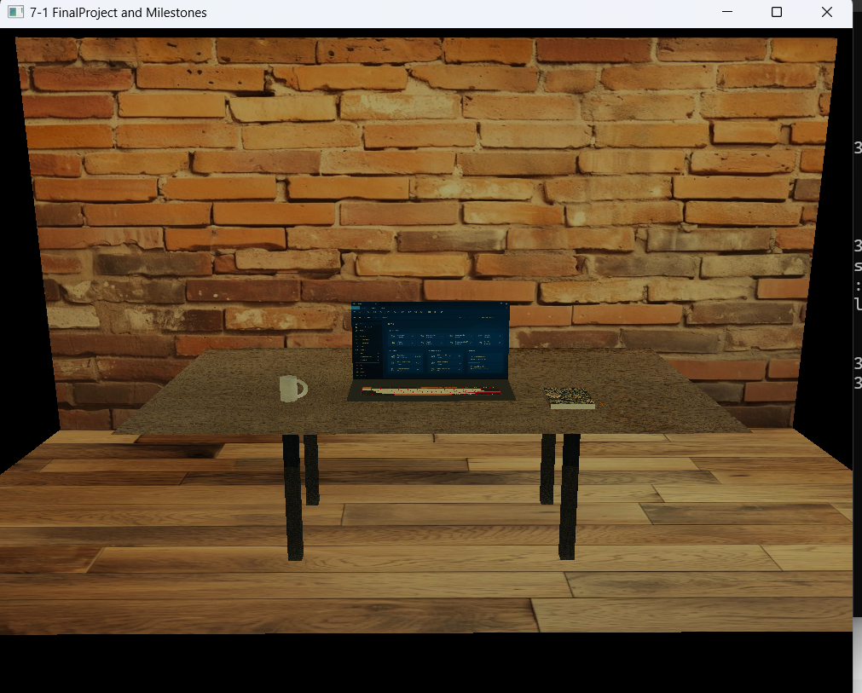

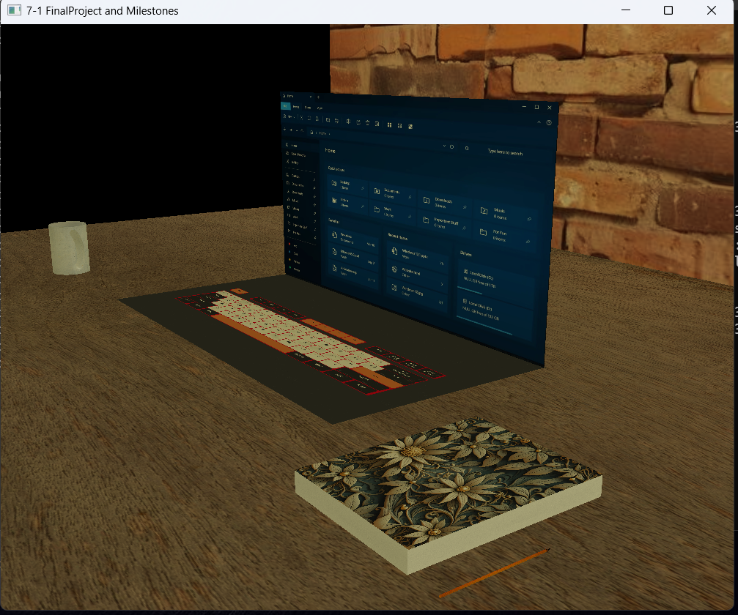

ZOOM 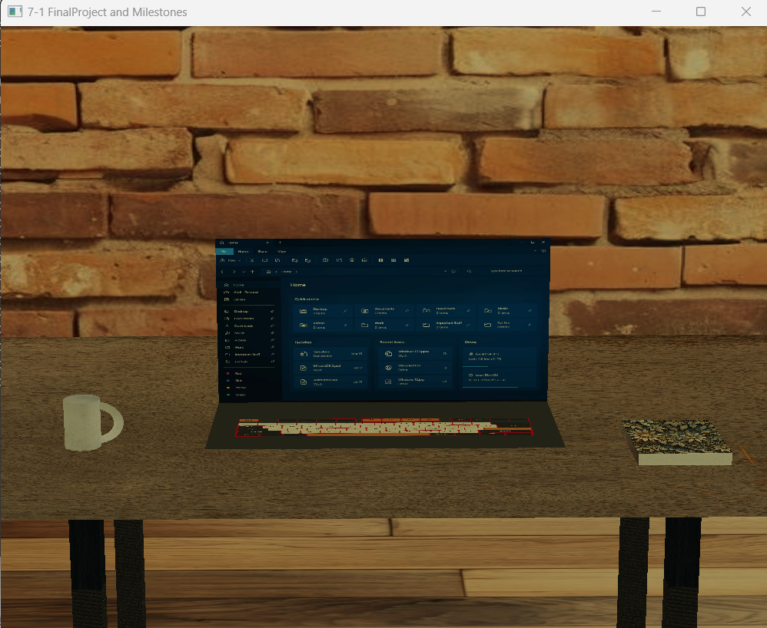

ORTHO VIEW 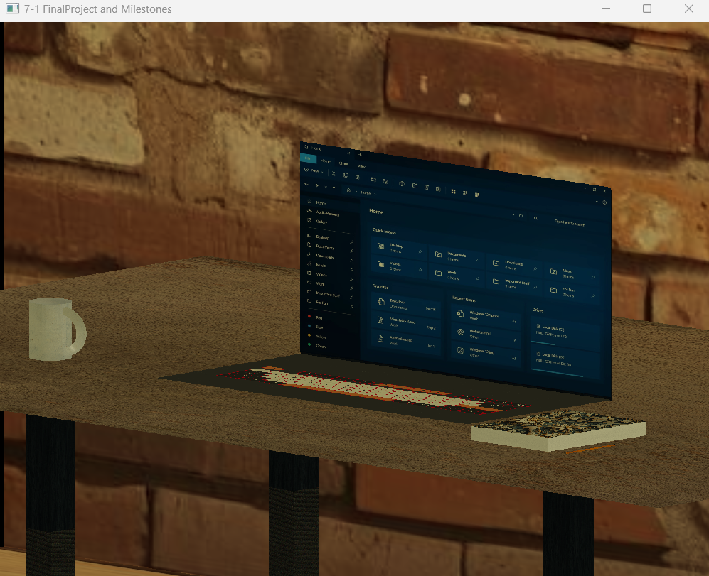

CUP (cylinder and half torus) 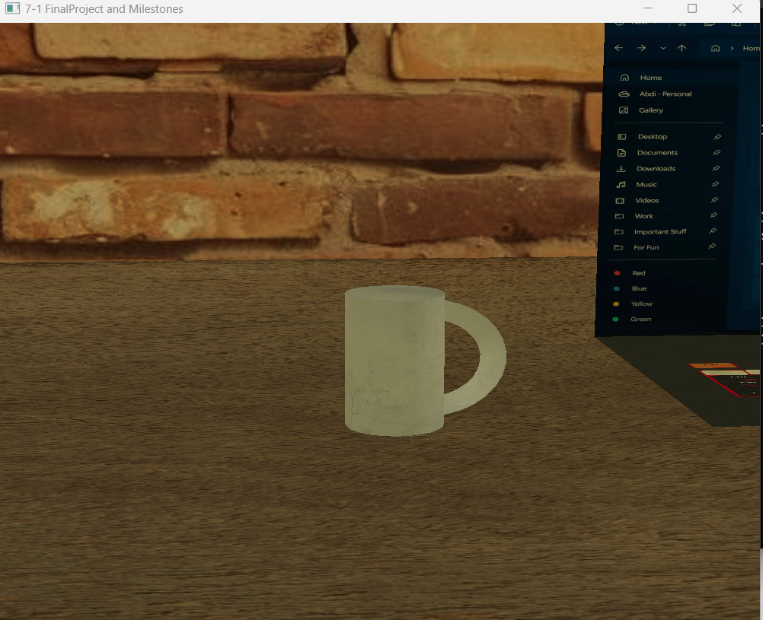

LAPTOP (planes) 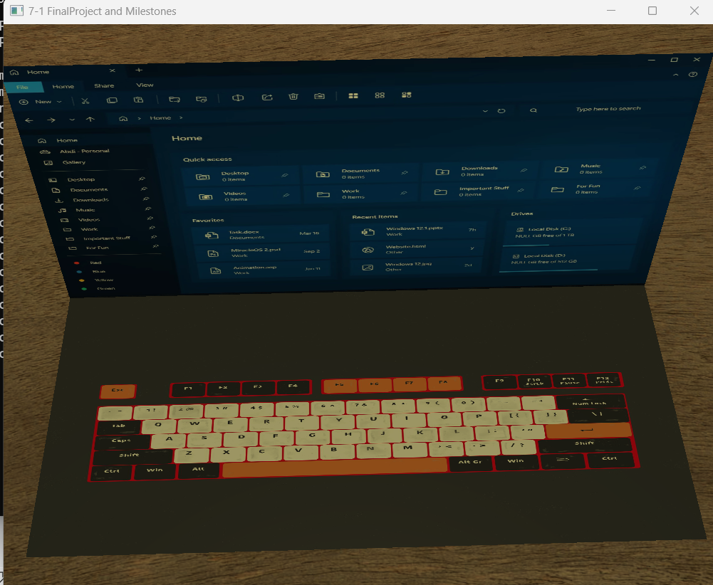

BOOK (PLANES For cover and BOX for paper)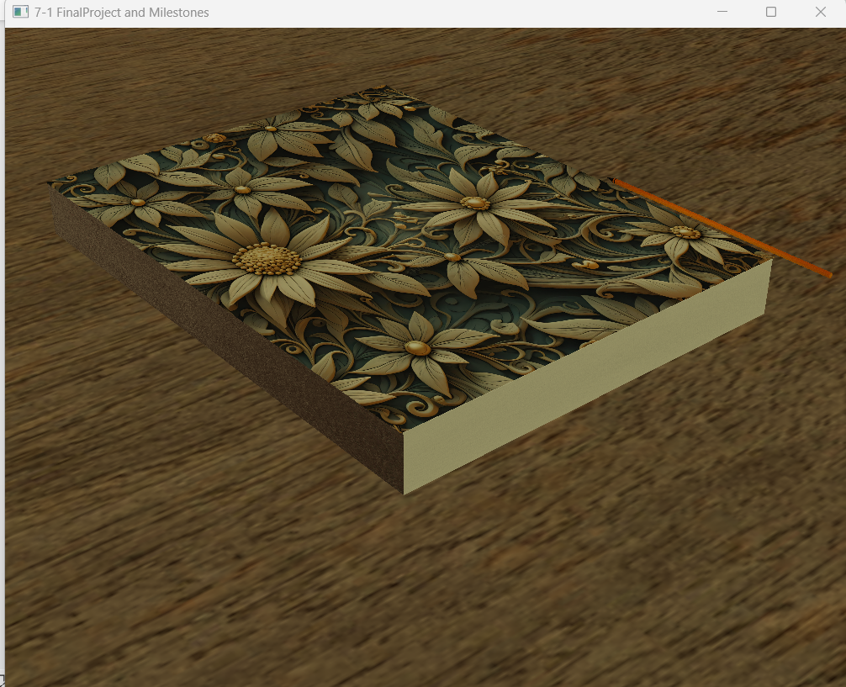

PENICL (cylinder and cone ) 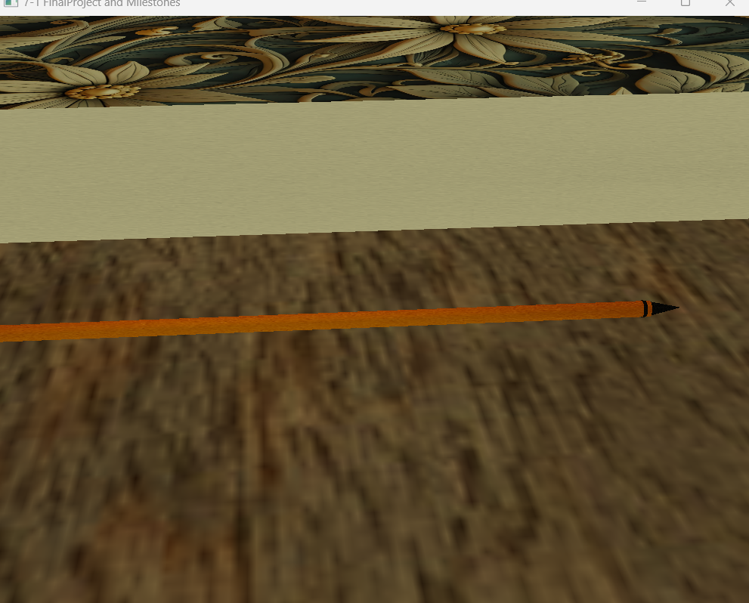

TABLE (BOX for legs and Plane for top) 